After a little more CAD work during our meeting tonight we have a tentative 3D model of the Da Vinci tube prototype.
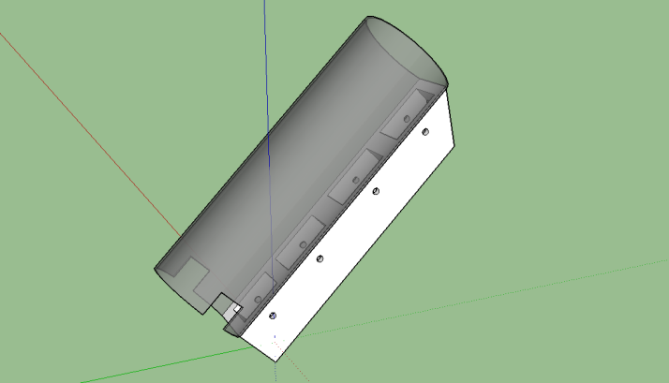

Khan's log
Star date 10/2/14
TODAY IS A GLORIOUS DAY!!!! Last night, NASA delivered the final components of the chassis, the KR4 rails. With the new rails we were able to complete the chassis and are now able to start running trials. The wiring has worked out just to plan with the wires concealed and protected inside of the modified C-channels.
KR4 chassis undergoing its first test runs.
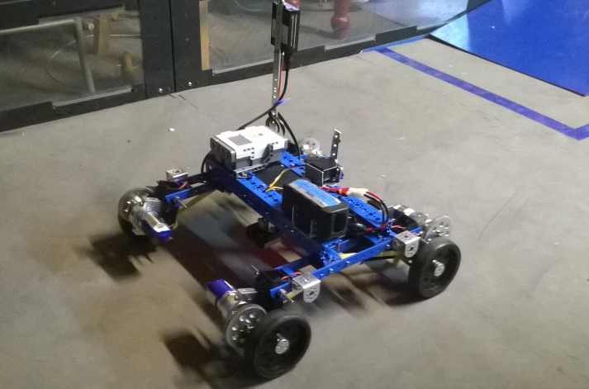
We also have a working model of the chassis so we can experiment with various arrangements of its modular parts as well experimenting with the geometry of our new prototypes.

Google SketchUp model of the KR4 chassis.
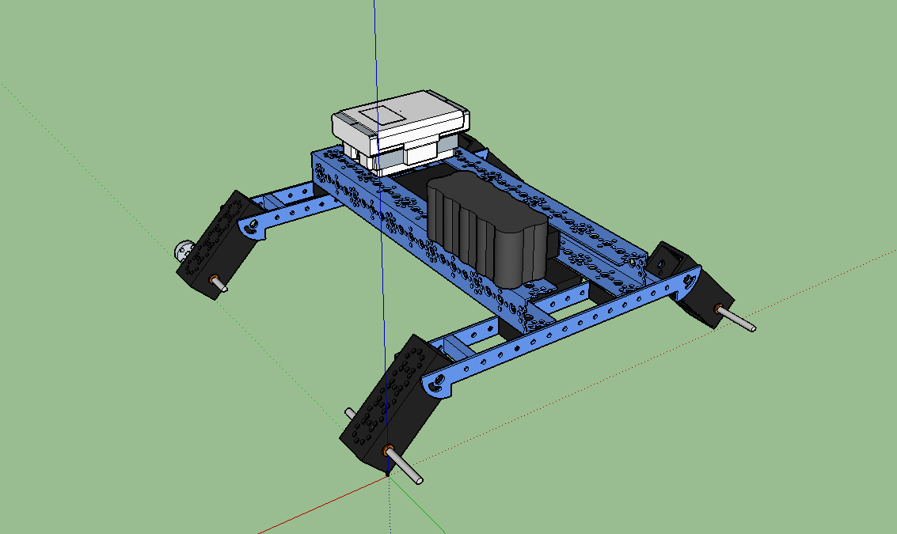
We are currently working on making a camera arm to enable us to mount a camera to watch how the suspension reacts to various obstacles on the field.
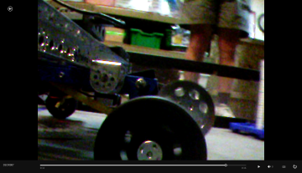 Suspension contracted.
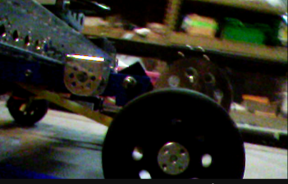 Suspension extended.
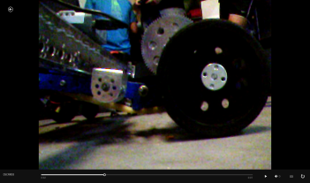 Suspension over extended. (BAD)
After further testing we have found that iff enough force is put on a nacelle, it will shater so to fix that we have made a new reinforced 3D model to be printed by NASA.

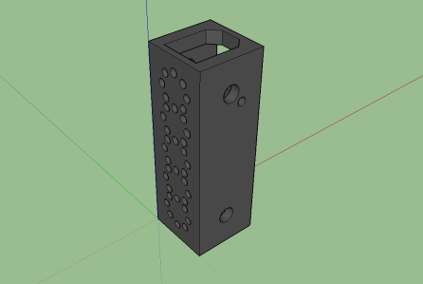

Khan's log
Star date 10/9/14
Work on the "Da Vinci" tube has progressed some and we now have a semi functioning tube. We have also opted to use a light sensor instead of an ultrasonic sensor to count the shadow of a passing ball. We also put LED strips in the tube to help the robot communicate visually with the drive team when it is fully loaded.
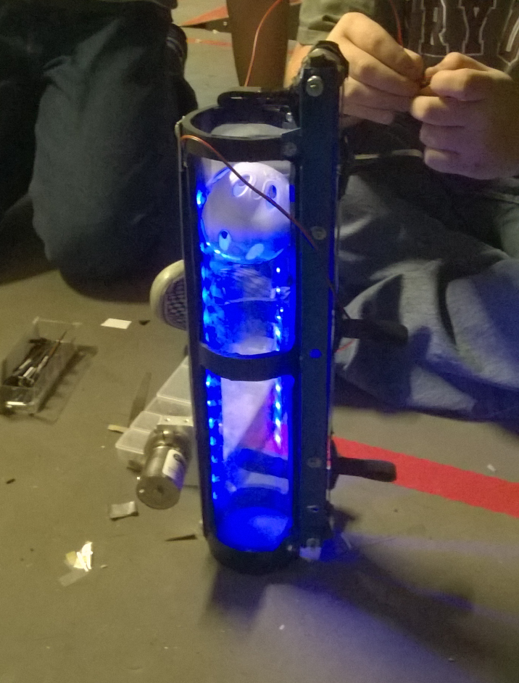

Khan's log
Star date 11/15/14
Well our house of cards has come crashing down. The four stage riser arm will not work no matter how many thing we try. We hypothesize that the problem lies in the sheer amount of resistance given by the chains. Three years ago the arm worked just fine because it was only two stages and weighed much less. We have also discovered that both the paddle wheels and our make shift duck tape conveyor belt have jamming issues when a ball comes into the tube. We have spent many hours working on correcting these problem and have already called several extra meetings however he have yet to see any improvement. We are considering scrapping this riser arm system in favor for something a bit simpler, like drawer sliders.
Four stage arm stored. Our facial expression.
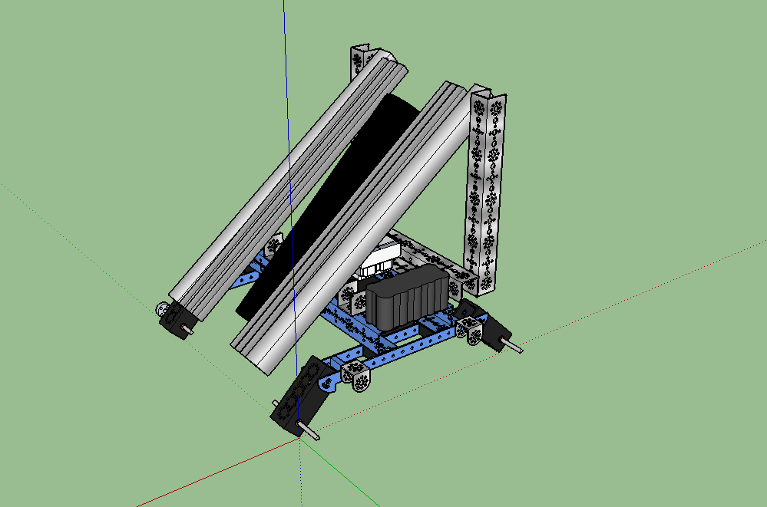
Four stage arm extended.
